EXP NO 7: DEMONSTRATE VIRTUALIZATION BY INSTALLING TYPE-2
HYPERVISOR IN YOUR DEVICE, CREATE AND CONFIGURE VM IMAGE
WITH A HOST OPERATING SYSTEM (EITHER WINDOWS/LINUX).
DATE:
AIM:
To demonstrate virtualization by installing type-2 hypervisor in your device, create and configure VM
image with a host operating system (either windows/linux).
PROCEDURE:
STEP 1:Dowload VMware workstation and installed as type 2hypervisor.
STEP2:Dowload ubuntu or tiny OS as iso image file.
STEP 3: In VMware workstation->create new VM.
STEP 4: Do the basic configuration settings.
STEP 5: Created tiny OS virtual machine.
STEP 6: Launch the VM.
IMPLEMENTATION:
STEP 1:DOWLOAD VMWARE WORKSTATIONAND INSTALLED AS TYPE 2HYPERVISOR
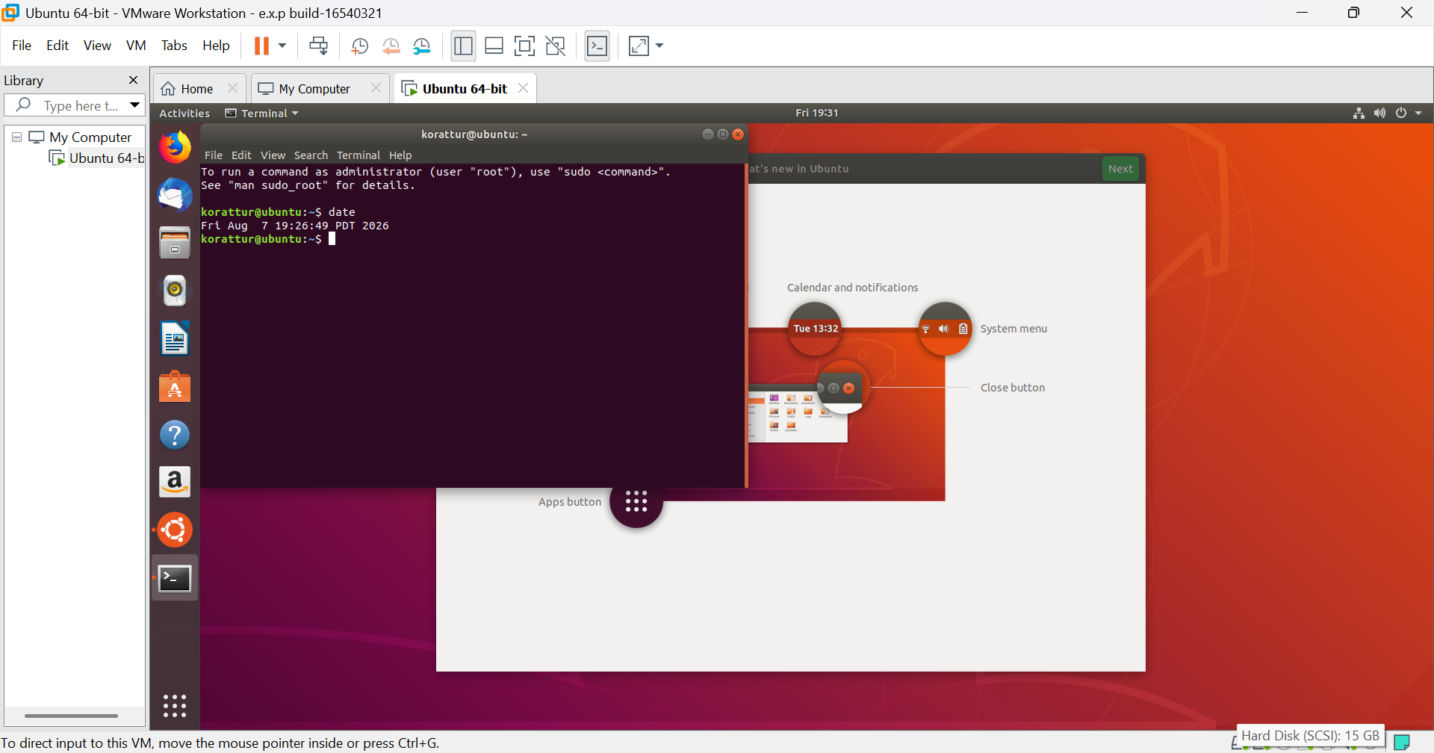

EXP 9: CREATE AVIRTUAL HARD DISK AND ALLOCATE THE STORAGEUSING VM WARE
WORKSTATION.
DATE:
AIM:
To create a virtual hard disk and allocate the storage using vm ware workstation
PROCEDURE:
STEP 1:GOTO VM WARE WORKSTATION.
STEP2: RIGHT CLICK THE VM AND GOTO THE SETTINGS.
STEP 3: ADD HARDWARE WIZARD AND SELECT SCSI AND CLICK NEXT.
STEP 4: CREATE NEW VIRTUAL DISK.
STEP 5: SELCT THE DISK SIZE AS 2.0. AND SELCT SPLIT VIRTUAL DISK INTOMULTIFILES.
STEP 6: GIVE NAME AND CLICK THE FINISH.

IMPLEMENTATION:
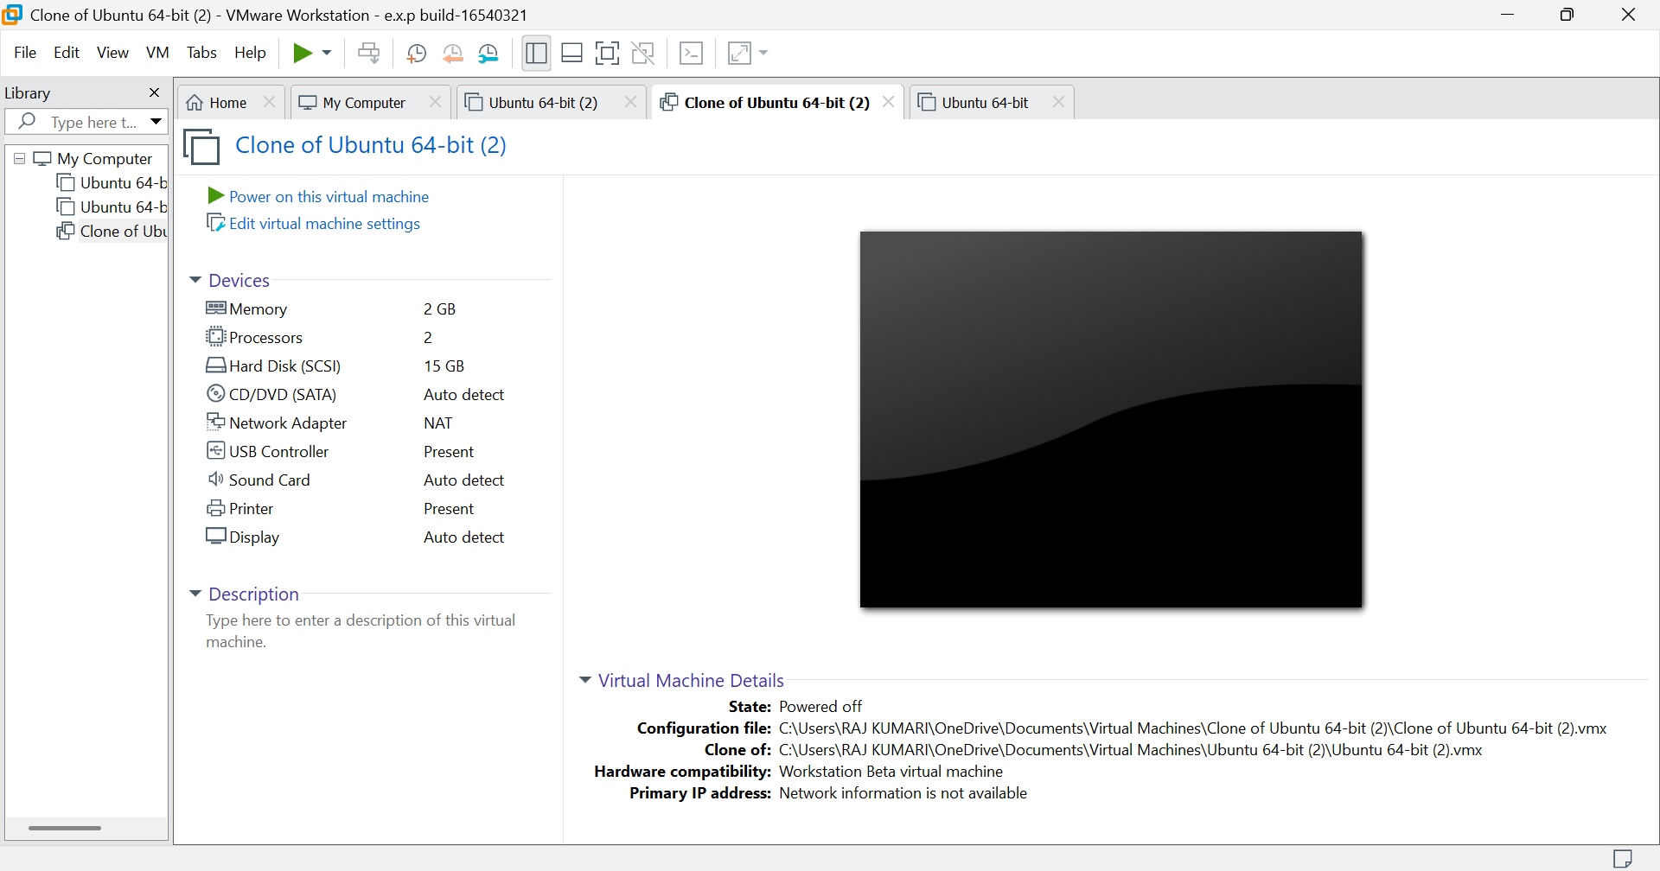

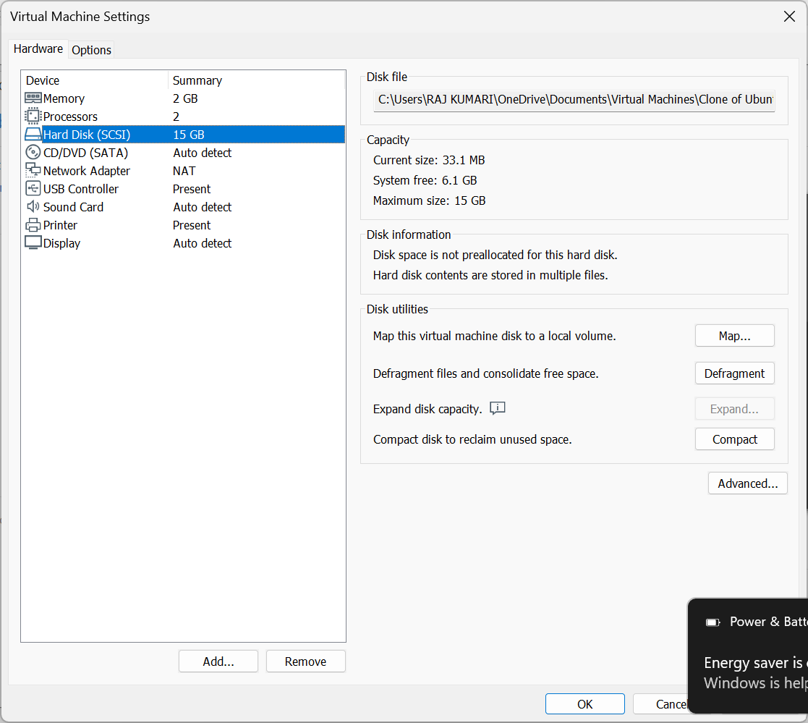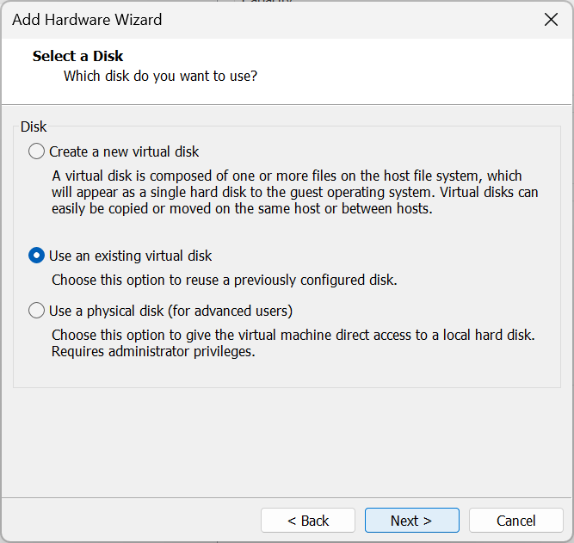
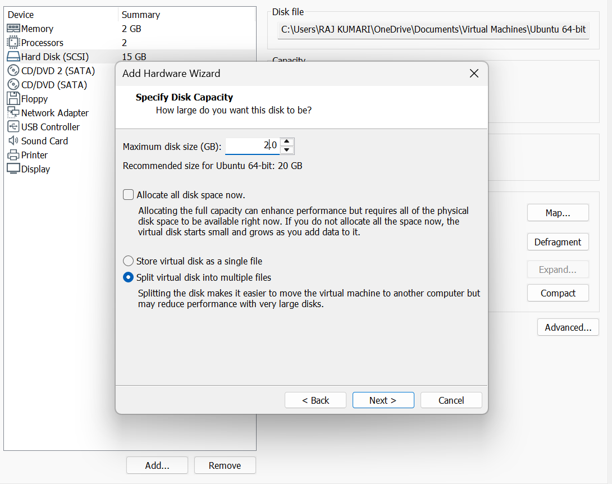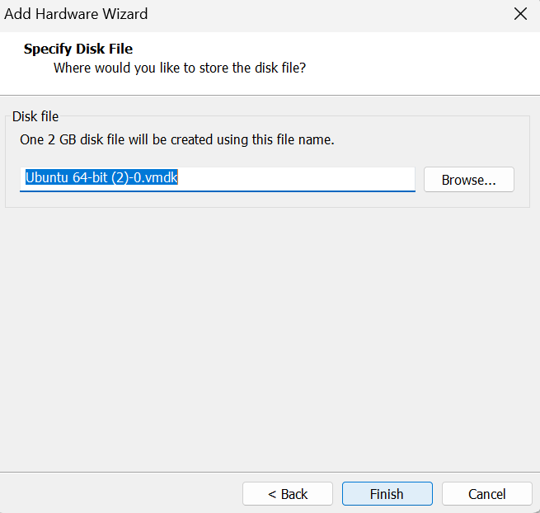

Result : this experiments was completed successfully and new memory was allocated.

Experiment 4: Demonstrate virtualization by Installing Type-2 Hypervisor in your device, create and configure VM image with a Host Operating system (Either Windows/Linux). Create a Cloning of a VM and Test it by loading the Previous Version/Cloned VM
Aim
To demonstrate virtualization using VMware Workstation (Type-2 Hypervisor) by creating a virtual machine, cloning it, and testing the cloned VM.
Procedure
- Install and open VMware Workstation on the Windows host system.
- Create a new virtual machine and install Ubuntu Linux as the guest OS.
- Configure the VM with suitable RAM, processor, storage, and network settings.
- Shut down the original VM and create a copy of its VM folder.
- Add the copied VM to VMware Workstation and name it Ubuntu Clone.
- Select “I Copied It” when VMware asks about the VM identity.
- Start the cloned VM and verify that Ubuntu and the previous files/configuration are loaded successfully.
Implementation:
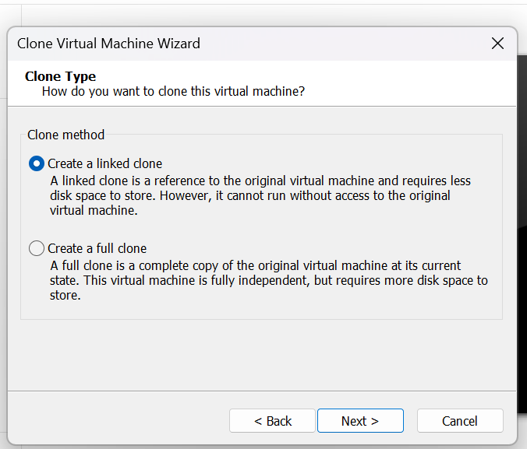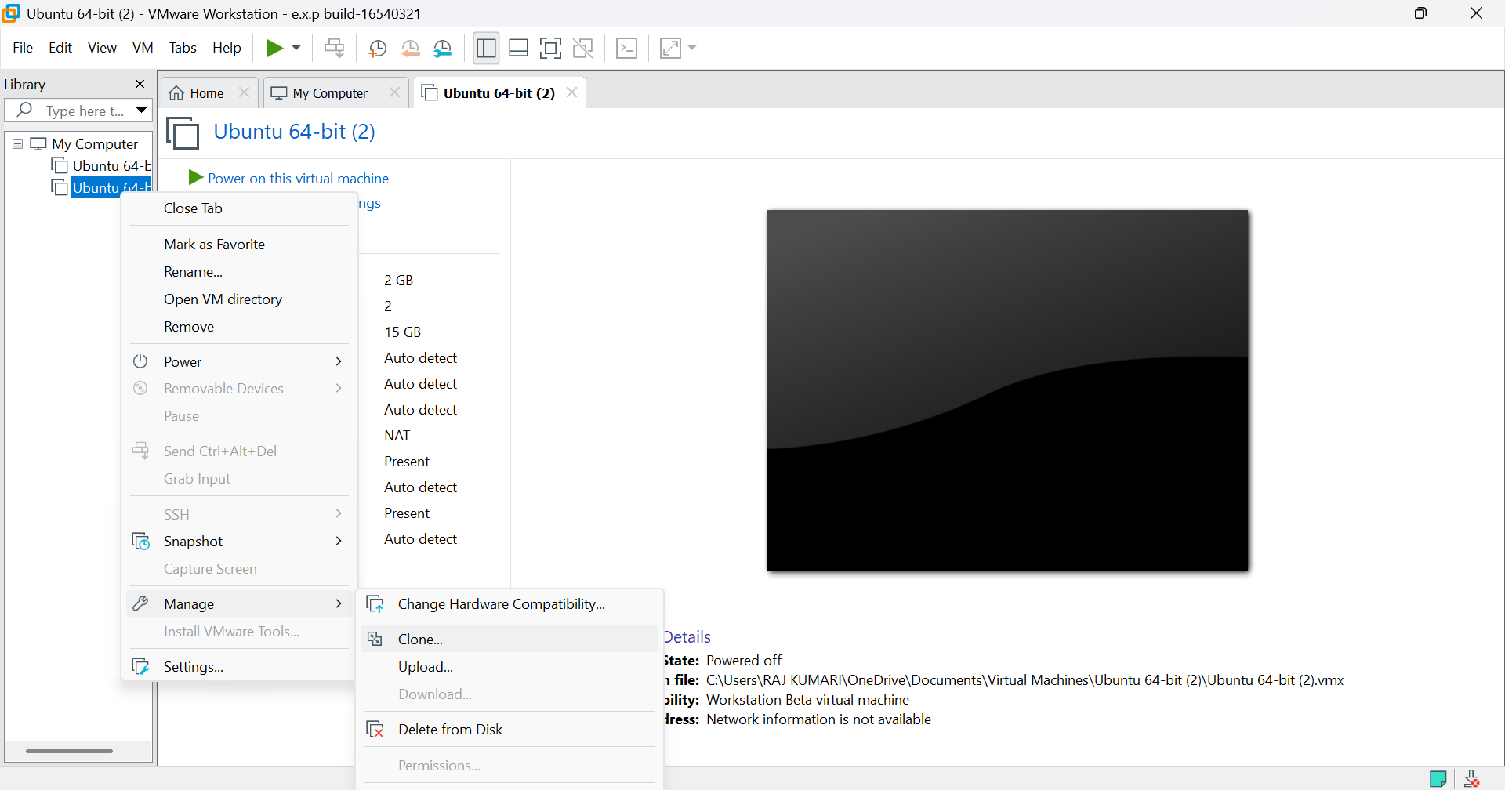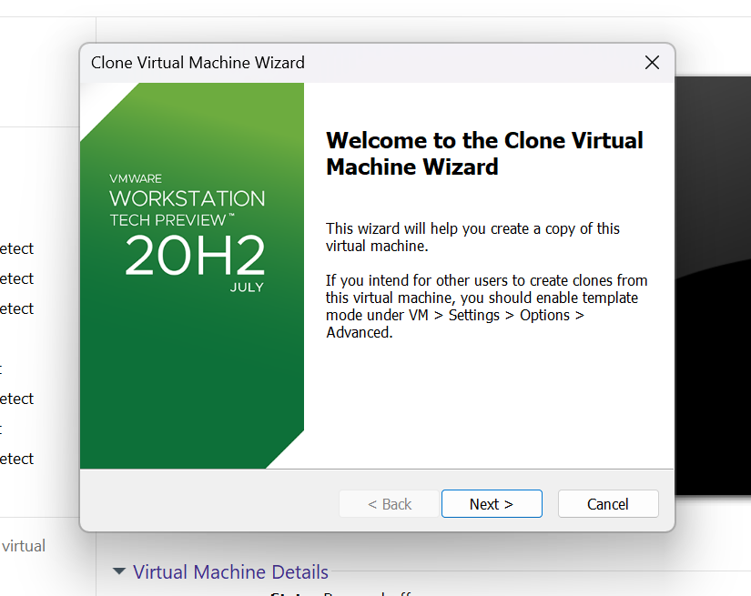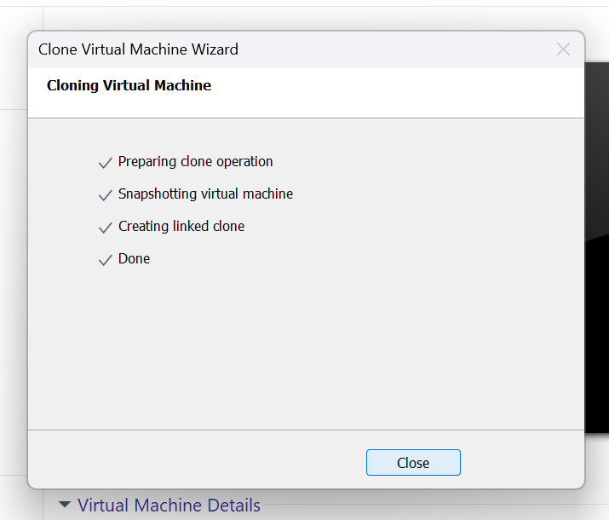

Result :
The Ubuntu virtual machine was successfully created using VMware Workstation, and a cloned VM was created and tested successfully, demonstrating Type-2 virtualization and VM cloning.

15. Create a Snapshot of a VM and Test it by loading the Previous Version/Cloned VM
Aim:
To create a snapshot of a Virtual Machine (VM) and test it by restoring/loading the previous version or cloned VM.
Procedure:
- Open the virtualization software and select the required VM.
- Create a snapshot of the VM and give it a suitable name.
- Make some changes to the VM.
- Restore/revert the VM to the created snapshot.
- Verify that the VM returns to its previous state.
- Alternatively, clone the VM and load the cloned version to verify its functionality.
Implementation:
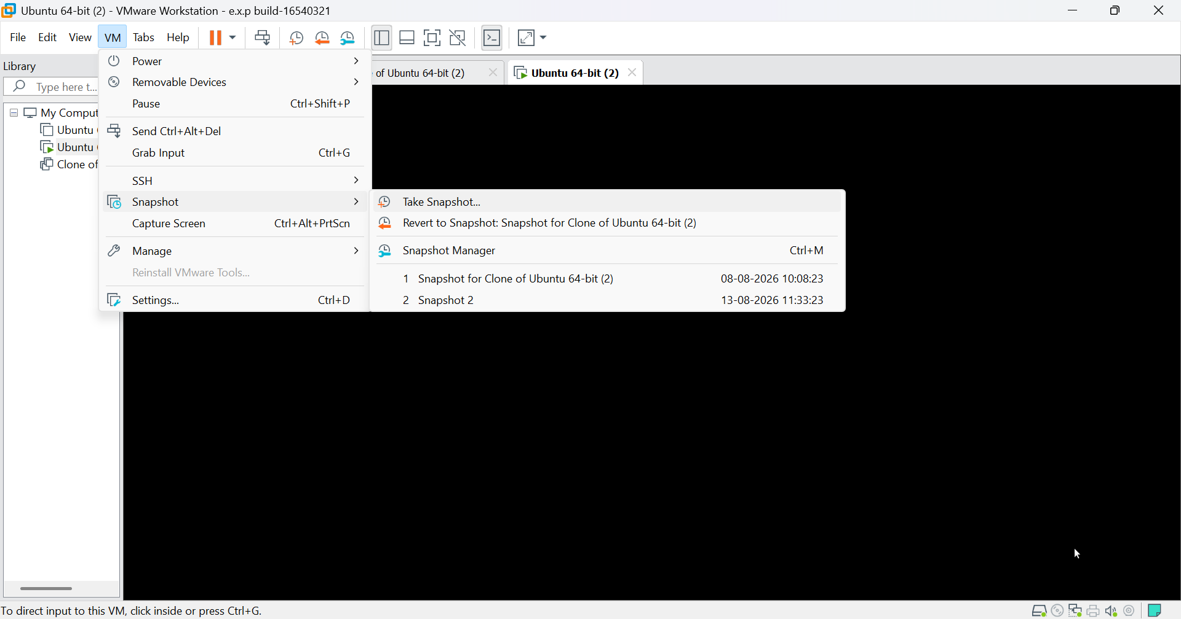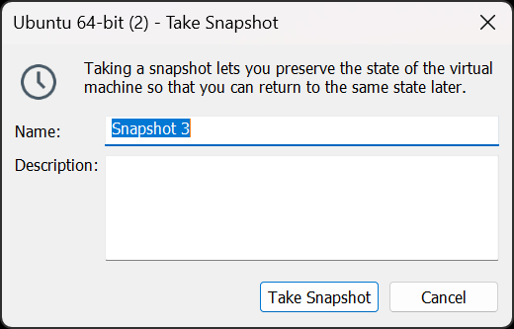
Result:
The VM snapshot was successfully created and restored. The previous state was recovered correctly, and the cloned VM was successfully loaded and tested.

Exp 19: Install C Compiler in a Virtual Machine and Execute C Programs
Aim:
To install a C compiler in a virtual machine created using VirtualBox/VMware and execute simple C programs.
Procedure:
- Start the VM and open the terminal.
- Install a C compiler such as GCC.
- Create a C program using a text editor.
- Save the file with a .c extension.
- Compile the program using the GCC compiler.
- Execute the generated program and verify the output.
Implementation:
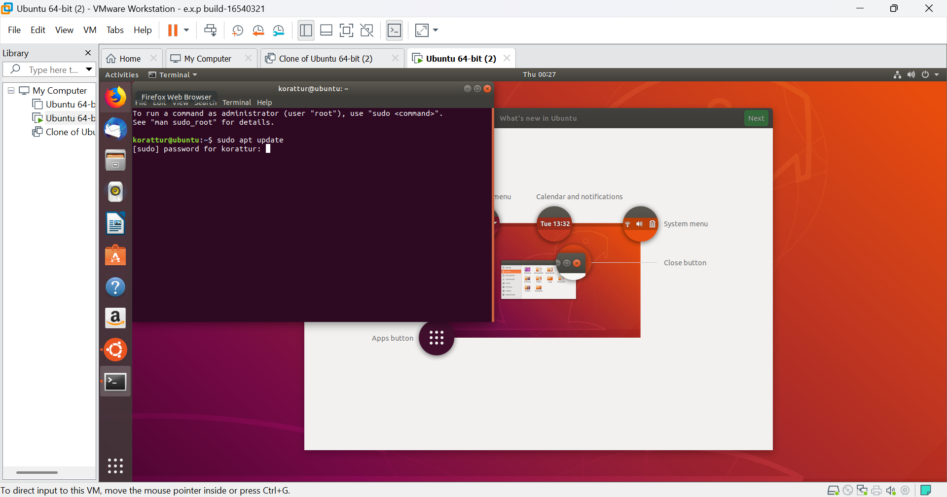
Result:
The C compiler was successfully installed in the virtual machine, and simple C programs were compiled and executed successfully.
Procedure: Attach a Virtual Block to a Virtual Machine and Verify Data Persistence
Aim
To attach a virtual block storage device to a Virtual Machine (VM), store data in it, release/remove the VM, and verify that the data remains available.
Requirements
- VMware Workstation
- An existing Linux/Ubuntu VM
- Sufficient disk space
Procedure
Step 1: Power Off the VM
- Open VMware Workstation.
- Select your Ubuntu VM.
- Make sure the VM is Powered Off.

Step 2: Create and Attach a Virtual Disk
- Select the VM.
- Click Edit virtual machine settings.
- Select Add...
- Select Hard Disk.
- Click Next. 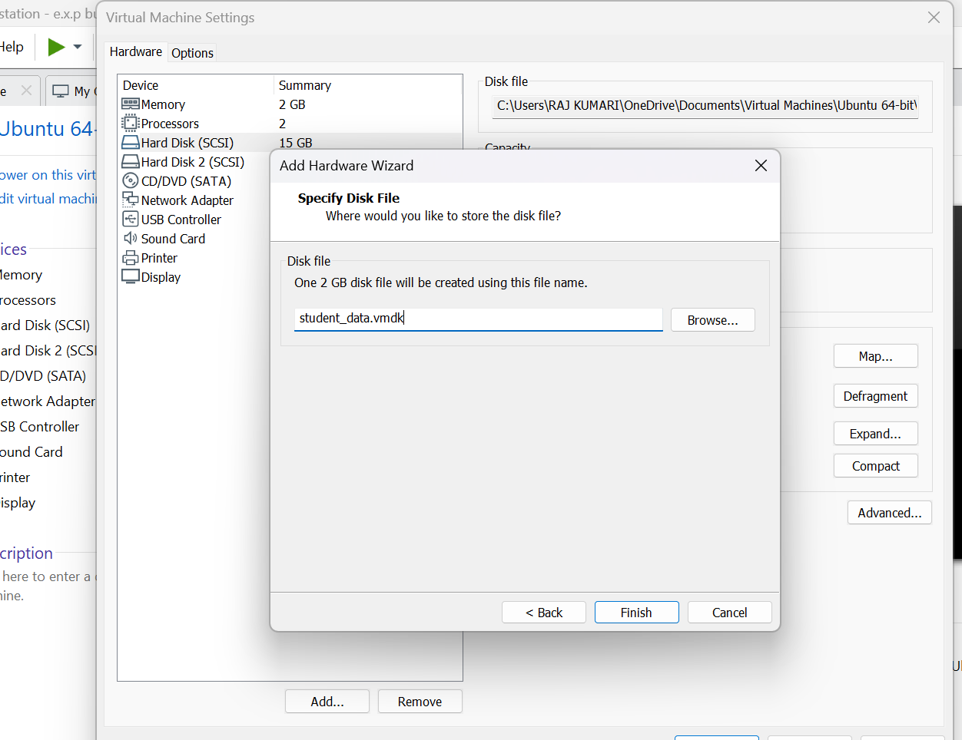
- Select SCSI or the default recommended virtual disk type.
- Select Create a new virtual disk.
- Specify the disk size, for example:
Size: 2 GB
- Select Store virtual disk as a single file or the default option.
- Give it a name such as:
student_data.vmdk
- Click Finish → OK.
The virtual disk is now attached to the VM.

Step 3: Start the VM
Start Ubuntu and open the Terminal.
Check the available disks:
lsblk
You should see the newly attached disk, for example:
sda 15G
├─sda1 ...
sdb 2G
Here, sdb is the newly attached virtual block device.
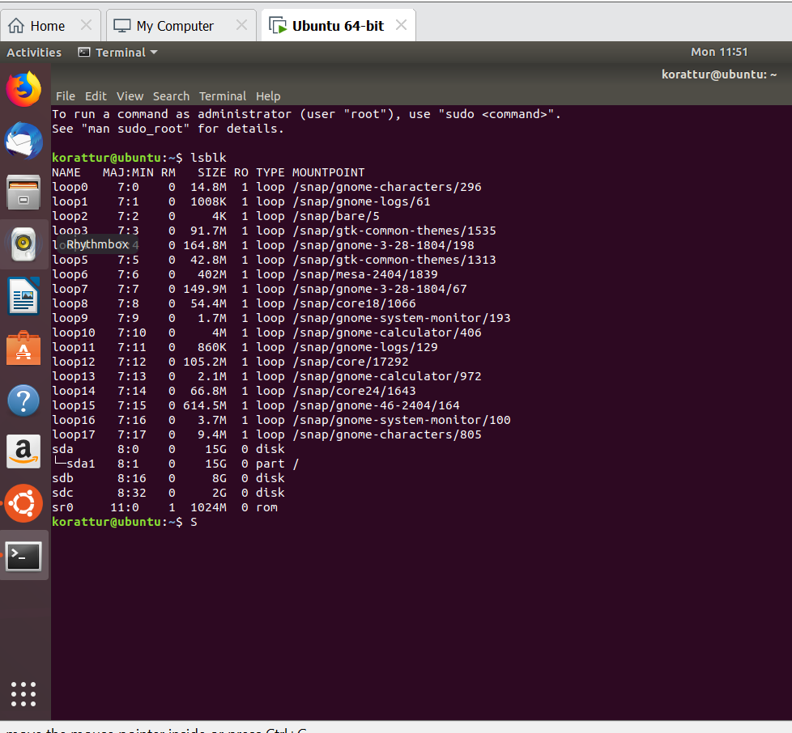

Step 4: Format the Virtual Disk
⚠️ Make sure you identify the new disk correctly before formatting it.
For example:
sudo mkfs.ext4 /dev/sdb

Step 5: Mount the Virtual Block
Create a mount point:
sudo mkdir /data
Mount the disk:
sudo mount /dev/sdb /data
Verify:
df -h
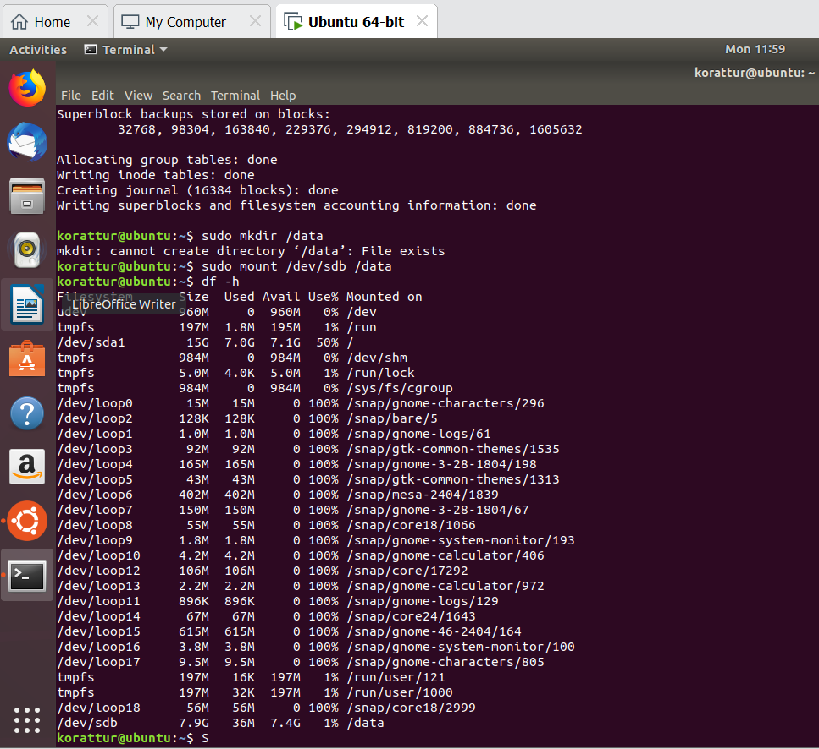

Step 6: Store Test Data
Create a file on the virtual disk:
echo "Virtual Block Storage Test" | sudo tee /data/test.txt
Check the contents:
cat /data/test.txt
Expected output:
Virtual Block Storage Test
You can also create another file:
sudo touch /data/student.txt
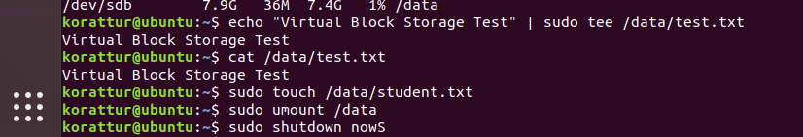

Step 7: Release the Virtual Machine
First unmount the virtual block:
sudo umount /data
Then shut down Ubuntu:
sudo shutdown now
After the VM is powered off, do not delete the .vmdk file.
This is important because the objective is to verify that the virtual block survives after the VM is released.

Step 8: Detach the Virtual Disk from the VM
In VMware Workstation:
VM → Settings → Hard Disk (the 2 GB disk) → Remove
Choose Remove from virtual machine, not "Delete from disk."
This demonstrates that the virtual block storage exists independently of the VM.

Step 9: Attach the Same Virtual Disk to Another VM
- Select another Linux VM.
- Edit virtual machine settings → Add → Hard Disk.
- Select Use an existing virtual disk.
- Browse to:
student_data.vmdk
- Select the disk.
- Click Finish → OK.
- Start the second VM.

Step 10: Mount and Verify the Data
Inside the second Ubuntu VM:
lsblk
Identify the virtual disk, for example /dev/sdb.
Mount it:
sudo mkdir /data
sudo mount /dev/sdb /data
Now check the previously created file:
cat /data/test.txt
Expected output:
Virtual Block Storage Test
This proves that the data persisted even after the original VM was released.

Expected Result
VM 1
│
├── Virtual Block (student_data.vmdk)
│
└── test.txt
↓
VM Released
↓
Virtual Block remains
↓
Attach to VM 2
↓
test.txt still exists
Conclusion
The virtual block storage was successfully attached to a VM, data was written to it, and the disk was detached from the original VM without deleting it. The same virtual disk was attached to another VM, and the previously stored data was successfully recovered. Therefore, virtual block storage provides persistent data independent of the lifecycle of the VM.
22)Procedure: Run Virtual Machines with Different Configurations and Determine the Maximum Number of VMs
Aim
To create and run virtual machines with different hardware configurations and determine how many virtual machines can be utilized simultaneously on a host system based on available CPU, RAM, and storage resources.
Requirements
- VMware Workstation
- Windows/Linux host system
- At least one Linux ISO, such as Ubuntu
- Sufficient RAM and storage

Procedure
Step 1: Check Host Resources
Before creating VMs, check the physical computer's resources.
In Windows:
Task Manager → Performance
Note the available:
- CPU cores
- RAM
- Disk space
For example:
Host Configuration
-------------------------
CPU : 8 cores
RAM : 16 GB
Storage : 100 GB available

Step 2: Create VM 1 – Small Configuration
In VMware Workstation:
File → New Virtual Machine → Typical
Install Ubuntu/Linux and configure:
VM 1
CPU : 1 core
RAM : 2 GB
Disk: 15 GB
Start the VM and verify that it works.

Step 3: Create VM 2 – Medium Configuration
Create another VM with:
VM 2
CPU : 2 cores
RAM : 4 GB
Disk: 20 GB
Start VM 2 while VM 1 is still running.

Step 4: Create VM 3 – Larger Configuration
Create another VM:
VM 3
CPU : 2 cores
RAM : 4 GB
Disk: 20 GB
Start VM 3.
Now you have:
Host Computer
│
├── VM 1 → 1 CPU, 2 GB RAM
├── VM 2 → 2 CPU, 4 GB RAM
└── VM 3 → 2 CPU, 4 GB RAM

Step 5: Monitor Resource Usage
Open Windows Task Manager → Performance while all VMs are running.
Observe:
- CPU utilization
- Memory utilization
- Disk utilization
You can also check VMware's VM resource usage.
For example:
VM | CPU | RAM | Status
VM 1 | 1 core | 2 GB | Running
VM 2 | 2 cores | 4 GB | Running
VM 3 | 2 cores | 4 GB | Running
Total allocated RAM:
2 + 4 + 4 = 10 GB
If the host has 16 GB RAM, approximately 6 GB remains for the host OS and VMware overhead.

Step 6: Determine Maximum Number of VMs
Continue creating/starting VMs with the selected configuration until the host reaches its practical resource limit.
For example, if using a 2 GB RAM configuration:
Host RAM = 16 GB

16 / 2 = 8 VMs
However, 8 VMs should not automatically be treated as the safe maximum, because the host OS and VMware also require RAM.
A practical calculation is:
Usable VM RAM =
Host RAM − Host OS reserve − VMware overhead
For example:
16 GB − 4 GB = 12 GB usable

12 / 2 = 6 VMs
Therefore, approximately 6 VMs could be run simultaneously in this example, subject to CPU, disk, and actual workload usage.

Step 7: Record the Observation
Use a table such as:
Number of VMs | Total RAM Allocated | CPU Allocation | Host Condition
1 | 2 GB | 1 core | Normal
2 | 4 GB | 2 cores | Normal
3 | 6 GB | 3 cores | Normal
4 | 8 GB | 4 cores | Normal
5 | 10 GB | 5 cores | Moderate
6 | 12 GB | 6 cores | High
7 | 14 GB | 7 cores | Very High / Not recommended
The exact results will depend on your computer.

Step 8: Identify the Resource Bottleneck
The maximum number of VMs is determined by the first major resource bottleneck, not just RAM.
For example:
Host Resources
│
┌──────────┼──────────┐
↓ ↓ ↓
CPU RAM Storage
│ │ │
↓ ↓ ↓
Limited Limited Limited
└──────────┼──────────┘
↓
Maximum practical VMs
If RAM becomes exhausted first, RAM is the bottleneck. If CPU reaches sustained high utilization first, CPU is the bottleneck.
Result
Virtual machines with different CPU, RAM, and storage configurations were successfully created and executed simultaneously in VMware Workstation. The maximum practical number of VMs was determined by monitoring CPU, RAM, storage, and host-system overhead.
24. To showcase the virtual machine migration based on the certain condition from one
host to the other.
aim : Showcase virtual machine migration based on certain conditions, from one host to another.
Procedure :
- Create the VM on Host A
- Create a test file
- Shut down the VM
- Export the VM from Host A
- Import the VM on Host B
- Start the VM on Host B
Implementation:
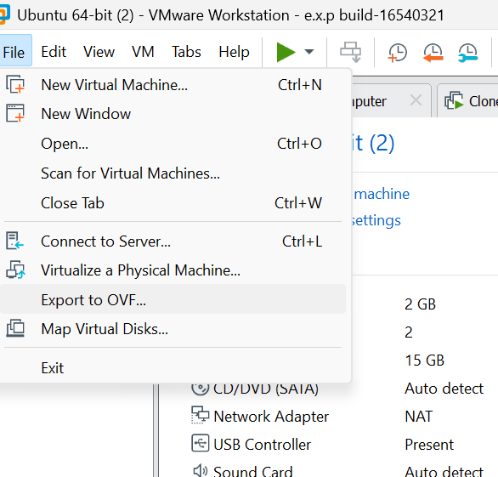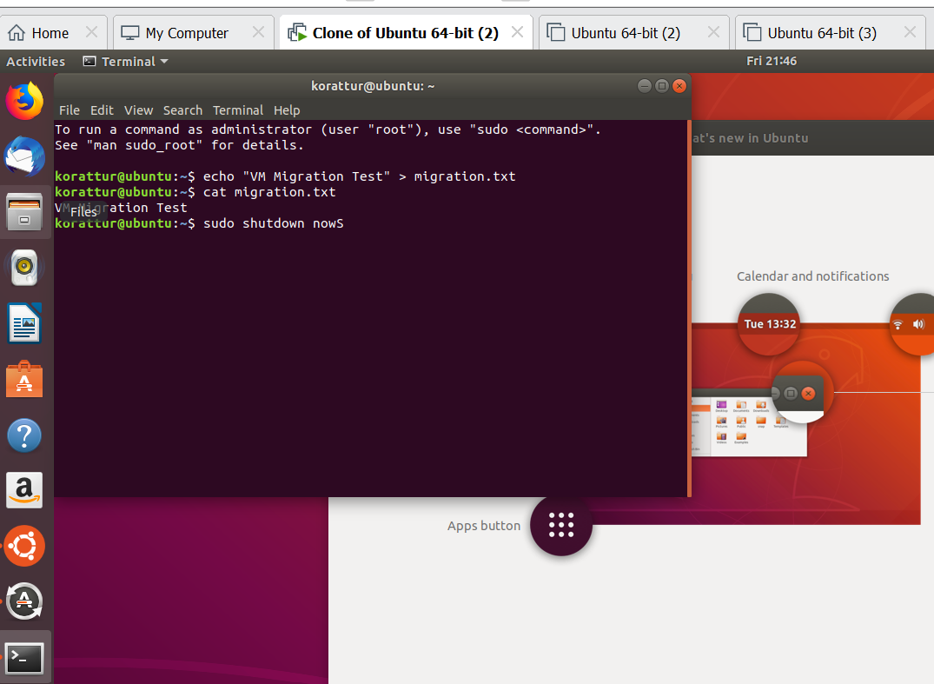
Result :
Successfully Showcased virtual machine migration based on certain conditions, from one host to another.

